**Task6 Engineering analysis in SW Simulation**

It is necessary to calculate the strength and stiffness of the assembly of the structure developed in Task5 using Solidworks Simulation or analog. Instructions for a specific site for calculation are given below.

General requirements:

• It is necessary to provide a report on the results of the calculation, containing information:

* **maximum stress and comparison with limit value,**

**for example:**

***” maximum stress = 125MPa ≤  180MPa = yield strength”***

* **maximum displasement**
* **factor of safety**

• The report is executed in .doc or .pdf format.

• Models are **NOT NECESSARY** to demonstrate, only a report.

• For evaluation, scoring is used for the correct fulfillment of the calculation requirements:

|  |  |  |
| --- | --- | --- |
| № | Requirements | Points |
| 1 | The maximum stress is determined correctly | 3 |
| 2 | The maximum displasement is determined correctly | 3 |
| 3 | The factor of safety is determined correctly and is **greater than or** **equal to 1** | 3 |

|  |  |  |
| --- | --- | --- |
| **Variant №** | **Scheme** | **Description** |
|  |  | Calculate the strength and stiffness of the item pos.1 when the maximum torque T = 270 N*m is applied from the side of the electric motor M |
|  |  | Calculate the strength and stiffness of the item pos.1 under the action of the maximum torque T = 140N *m on the side of the electric motor M |
|  |  | Calculate the strength and stiffness of the item pos.4 under the action of the maximum torque T = 220N *m on the side of the electric motor M |
|  |  | Calculate the strength and stiffness of the item pos.1 when the maximum torque T = 200 N*m is applied from the side of the electric motor M |
|  |  | Calculate the strength and stiffness of the item pos.4 when the maximum torque T = 180 N*m is applied from the side of the electric motor M |
|  |  | Calculate the strength and stiffness of the item pos.1 when the maximum torque T = 120N*m is applied from the side of the electric motor M |
|  |  | Calculate the strength and stiffness of the item pos.3 under the action of maximum force F = 800 N with fixed links 1 and 2 |
|  |  | Calculate the strength and stiffness of the part item 1 under the action of maximum force from the spring side F = 100 N |
|  |  | Calculate the strength and stiffness of the item pos.1 when the maximum torque T = 130 N*m is applied from the side of the electric motor M |
|  |  | Calculate the strength and stiffness of the item pos.1 when the maximum torque T = 130 N*m is applied from the side of the electric motor M |
|  |  | Calculate the strength and stiffness of the item pos.1 when the maximum torque T = 190 N*m is applied from the side of the electric motor M |
|  |  | Calculate the strength and stiffness of the item pos.1 under the action of the maximum torque T = 210N *m on the side of the electric motor M |
|  |  | Calculate the strength and stiffness of the item pos.1 when the maximum torque T = 300 N*m is applied from the side of the electric motor M |
|  |  | Calculate the strength and stiffness of the item pos.1 under the action of the maximum torque T = 290N *m on the side of the electric motor M |
|  |  | Calculate the strength and stiffness of the item pos.2 under the action of maximum force F = 600 N with fixed links 3 and 4 |
| 0. |  | Calculate the strength and stiffness of the item pos.1 when the maximum torque T = 200N*m is applied from the side of the electric motor M |

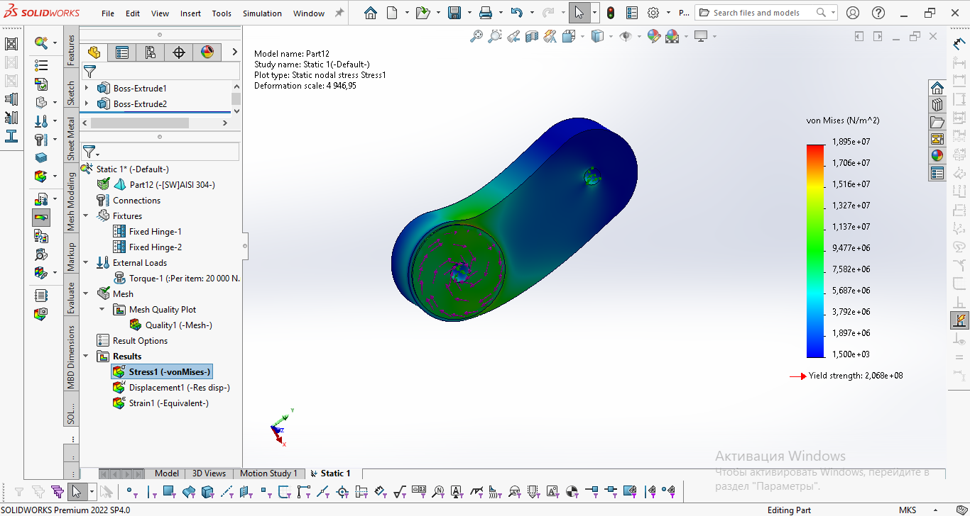



***maximum stress = 18.95MPa ≤  206.8MPa = yield strength***



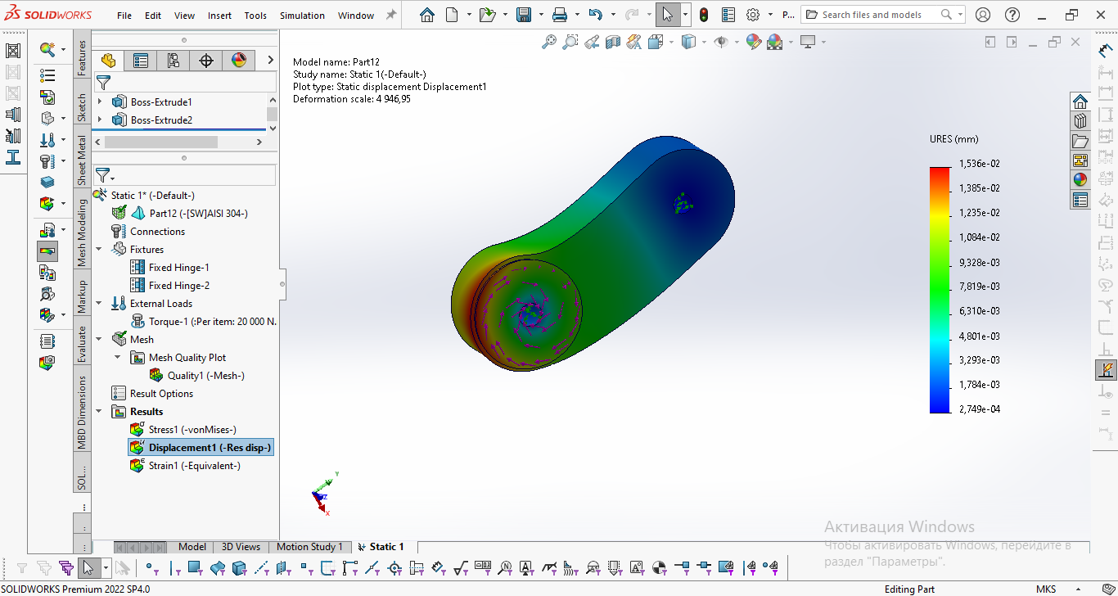

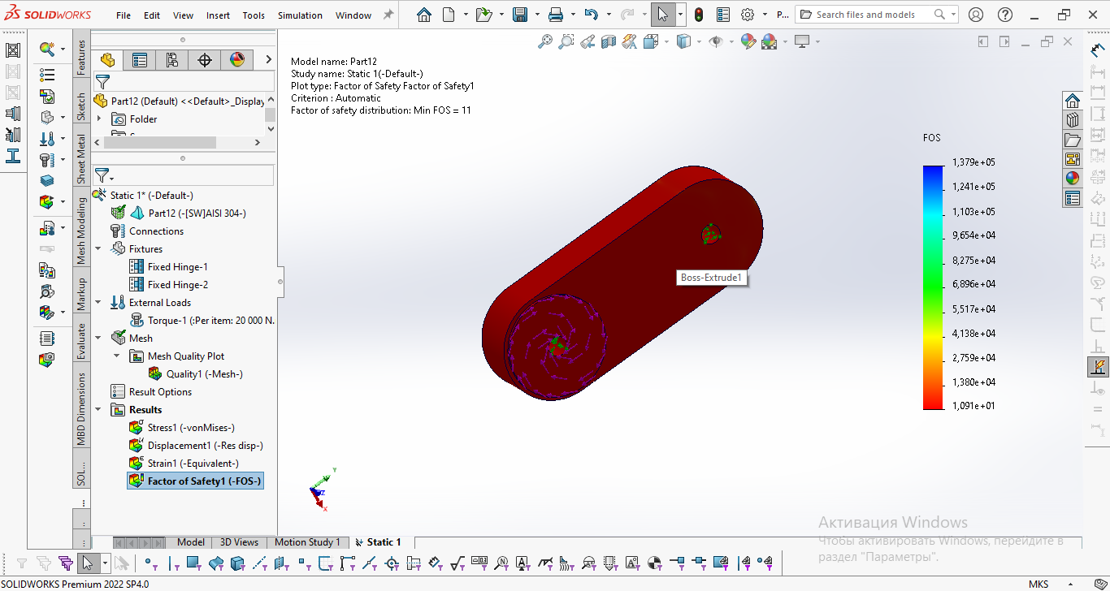



FoS min = 10

